Mike YU, Elmira Amanollahi and Laurian Staicu

Database MyBibliotheque

Data Dictionary for the assignment of DATABASE II

The Library Database Case Study provides an overview of the operations at the

West Municipal Library, describes the daily library functions, and presents the

database that was designed for the library.

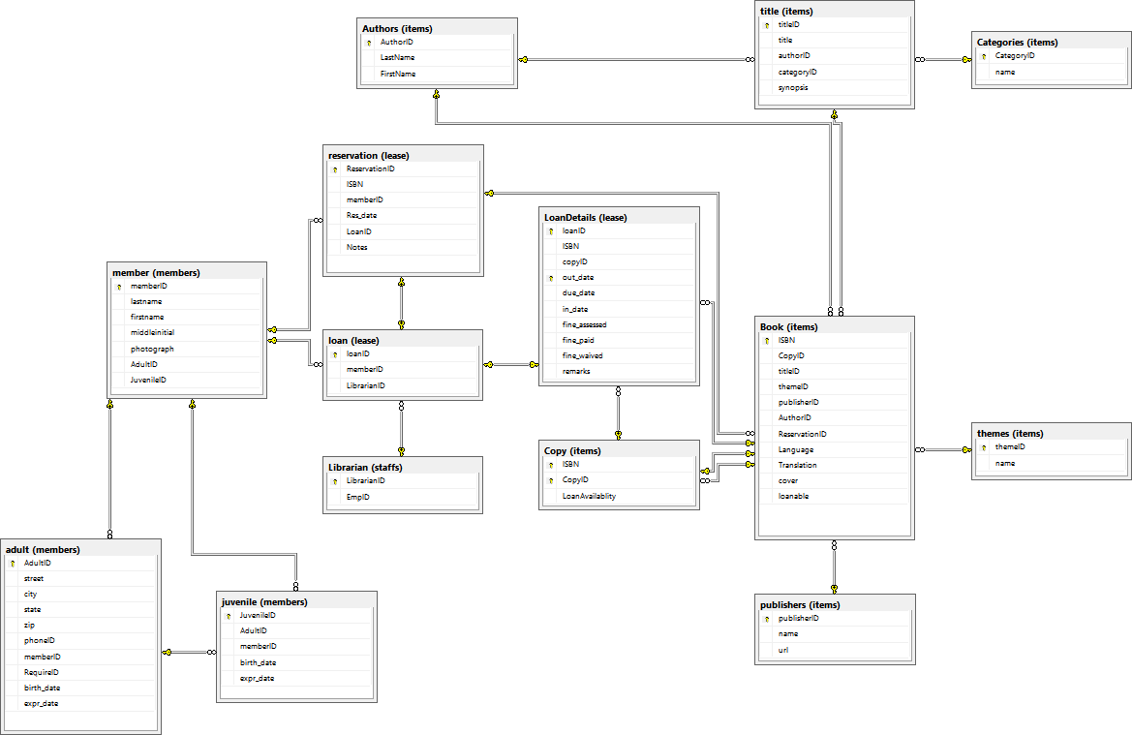

# Tables:

**items.Authors** 1

**items.Book**  1

**items.Categories**  1

**items.Copy**  2

**items.publishers**  2

**items.themes**  2

**items.title**  3

**lease.loan**  3

**lease.LoanDetails**  3

**lease.reservation**  4

**members.adult**  4

**members.juvenile**  5

**members.member**  5

**staffs.Librarian**  6

**I**

# Tables:

**Table items.Authors**

|  |  |  |  |  |  |
| --- | --- | --- | --- | --- | --- |
|  | **Column** | **Data Type** | **Identity** | **Nullable** | **Default** |
| **PK** | AuthorID | int | X |  |  |
|  | LastName | nchar(20) |  |  |  |
|  | FirstName | nchar(20) |  |  |  |

Indexes:

**PK_authors** *(Primary Key) (Clustered)*

AuthorID

Referenced by:

**items.Book***(AuthorID)*

**items.title***(authorID -> AuthorID)*

**Table items.Book** *(0 rows)*

|  |  |  |  |  |  |
| --- | --- | --- | --- | --- | --- |
|  | **Column** | **Data Type** | **Identity** | **Nullable** | **Default** |
| **PK, FK** | ISBN | int |  |  |  |
| **FK** | CopyID | int |  |  |  |
| **FK** | titleID | int |  |  |  |
| **FK** | themeID | int |  |  |  |
| **FK** | publisherID | int |  |  |  |
| **FK** | AuthorID | int |  |  |  |
| **FK** | ReservationID | int |  | X |  |
|  | Language | varchar(15) |  |  |  |
|  | Translation | varchar(200) |  | X |  |
|  | cover | image |  | X |  |
|  | loanable | varchar(200) |  | X |  |

Indexes:

**pk_book** *(Primary Key) (Clustered)*

ISBN

References:

**items.Authors***(AuthorID)* **items.Copy***(CopyID, ISBN)* **items.publishers***(publisherID)* **items.themes***(themeID)* **items.title***(titleID)* **lease.reservation***(ReservationID)*

Referenced by:

**items.Copy***(ISBN)*

**lease.LoanDetails***(ISBN)*

**Table items.Categories**

|  |  |  |  |  |  |
| --- | --- | --- | --- | --- | --- |
|  | **Column** | **Data Type** | **Identity** | **Nullable** | **Default** |
| **PK** | CategoryID | int |  |  |  |
|  | name | varchar(50) |  |  |  |

Indexes:

**PK_categories** *(Primary Key) (Clustered)*

CategoryID

Referenced by:

**items.title***(categoryID -> CategoryID)*

**Table items.Copy**

|  |  |  |  |  |  |
| --- | --- | --- | --- | --- | --- |
|  | **Column** | **Data Type** | **Identity** | **Nullable** | **Default** |
| **PK, FK** | ISBN | int |  |  |  |
| **PK** | CopyID | int |  |  |  |
|  | LoanAvailablity | tinyint |  |  |  |

Indexes:

**pk_copy** *(Primary Key) (Clustered)*

ISBN

CopyID

References:

**items.Book***(ISBN)*

Referenced by:

**items.Book***(CopyID, ISBN)*

**lease.LoanDetails***(copyID, ISBN -> CopyID, ISBN)*

**Table items.publishers**

|  |  |  |  |  |  |
| --- | --- | --- | --- | --- | --- |
|  | **Column** | **Data Type** | **Identity** | **Nullable** | **Default** |
| **PK** | publisherID | int |  |  |  |
|  | name | varchar(50) |  |  |  |
|  | url | varchar(50) |  | X |  |

Indexes:

**PK_publishers** *(Primary Key) (Clustered)*

publisherID

Referenced by:

**items.Book***(publisherID)*

**Table items.themes**

|  |  |  |  |  |  |
| --- | --- | --- | --- | --- | --- |
|  | **Column** | **Data Type** | **Identity** | **Nullable** | **Default** |
| **PK** | themeID | int | X |  |  |
|  | name | varchar(50) |  |  |  |

Indexes:

**PK_themes** *(Primary Key) (Clustered)*

themeID

Referenced by:

**items.Book***(themeID)*

**Table items.title**

|  |  |  |  |  |  |
| --- | --- | --- | --- | --- | --- |
|  | **Column** | **Data Type** | **Identity** | **Nullable** | **Default** |
| **PK** | titleID | int | X |  |  |
|  | title | varchar(200) |  |  |  |
| **FK** | authorID | int |  | X |  |
| **FK** | categoryID | int |  | X |  |
|  | synopsis | varchar(400) |  | X |  |

Indexes:

**pk_title** *(Primary Key) (Clustered)*

titleID

References:

**items.Authors***(authorID -> AuthorID)*

**items.Categories***(categoryID -> CategoryID)*

Referenced by:

**items.Book***(titleID)*

**Table lease.loan**

|  |  |  |  |  |  |
| --- | --- | --- | --- | --- | --- |
|  | **Column** | **Data Type** | **Identity** | **Nullable** | **Default** |
| **PK, FK** | loanID | int | X |  |  |
| **FK** | memberID | int |  |  |  |
| **FK** | LibrarianID | int |  |  |  |

Indexes:

**PK_loan** *(Primary Key) (Clustered)*

loanID

References:

**lease.reservation***(loanID -> LoanID)* **members.member***(memberID)* **staffs.Librarian***(LibrarianID)*

Referenced by:

**lease.LoanDetails***(loanID)*

**Table lease.LoanDetails**

|  |  |  |  |  |  |
| --- | --- | --- | --- | --- | --- |
|  | **Column** | **Data Type** | **Identity** | **Nullable** | **Default** |
| **PK, UK, FK** | loanID | int |  |  |  |
| **FK** | ISBN | int |  |  |  |
| **FK** | copyID | int |  |  |  |
| **PK** | out_date | datetime |  |  |  |
|  | due_date | datetime |  |  |  |
|  | in_date | datetime |  | X |  |
|  | fine_assessed | money |  | X |  |
|  | fine_paid | money |  | X |  |
|  | fine_waived | money |  | X |  |
|  | remarks | varchar(200) |  | X |  |

Indexes:

**PK_LoanDetails** *(Primary Key) (Clustered)*

loanID out_date

loanID

References:

**items.Book***(ISBN)*

**items.Copy***(copyID, ISBN -> CopyID, ISBN)*

**lease.loan***(loanID)*

**Table lease.reservation**

|  |  |  |  |  |  |
| --- | --- | --- | --- | --- | --- |
|  | **Column** | **Data Type** | **Identity** | **Nullable** | **Default** |
| **PK** | ReservationID | int | X |  |  |
|  | ISBN | int |  |  |  |
| **FK** | memberID | int |  |  |  |
|  | Res_date | datetime |  |  |  |
| **UK** | LoanID | int |  |  |  |
|  | Notes | varchar(200) |  |  |  |

Indexes:

**pk_reservation** *(Primary Key) (Clustered)*

ReservationID

LoanID

References:

**members.member***(memberID)*

Referenced by:

**items.Book***(ReservationID)*

**lease.loan***(loanID -> LoanID)*

**Table members.adult** *(0 rows)*

|  |  |  |  |  |  |
| --- | --- | --- | --- | --- | --- |
|  | **Column** | **Data Type** | **Identity** | **Nullable** | **Default** |
| **PK** | AdultID | int |  |  |  |
|  | street | varchar(20) |  |  |  |
|  | city | varchar(20) |  |  |  |
|  | state | varchar(20) |  |  |  |
|  | zip | varchar(20) |  | X |  |
|  | phoneID | varchar(20) |  | X |  |
| **FK** | memberID | int |  |  |  |
|  | RequireID | varchar(20) |  |  |  |
|  | birth_date | datetime |  |  |  |
|  | expr_date | datetime |  |  |  |

Indexes:

**pk_adult** *(Primary Key) (Clustered)*

AdultID

References:

**members.member***(memberID)*

Referenced by:

**members.juvenile***(AdultID)*

**Table members.juvenile**

|  |  |  |  |  |  |
| --- | --- | --- | --- | --- | --- |
|  | **Column** | **Data Type** | **Identity** | **Nullable** | **Default** |
| **PK** | JuvenileID | int |  |  |  |
| **FK** | AdultID | int |  |  |  |
| **FK** | memberID | int |  |  |  |
|  | birth_date | datetime |  |  |  |
|  | expr_date | datetime |  |  |  |

Indexes:

**pk_juvenile** *(Primary Key) (Clustered)*

JuvenileID

References:

**members.adult***(AdultID)*

**members.member***(memberID)*

**Table members.member**

|  |  |  |  |  |  |
| --- | --- | --- | --- | --- | --- |
|  | **Column** | **Data Type** | **Identity** | **Nullable** | **Default** |
| **PK** | memberID | int | X |  |  |
|  | lastname | varchar(20) |  |  |  |
|  | firstname | varchar(20) |  |  |  |
|  | middleinitial | varchar(4) |  | X |  |
|  | photograph | varbinary(max) |  | X |  |
|  | AdultID | int |  | X |  |
|  | JuvenileID | int |  | X |  |

Indexes:

**pk_member** *(Primary Key) (Clustered)*

memberID

Referenced by:

**lease.loan***(memberID)* **lease.reservation***(memberID)* **members.adult***(memberID)* **members.juvenile***(memberID)*

**Table staffs.Librarian**

|  |  |  |  |  |  |
| --- | --- | --- | --- | --- | --- |
|  | **Column** | **Data Type** | **Identity** | **Nullable** | **Default** |
| **PK** | LibrarianID | int | X |  |  |
|  | EmpID | int |  |  |  |

Indexes:

**PK_Librarian** *(Primary Key) (Clustered)*

LibrarianID

Referenced by:

**lease.loan***(LibrarianID)*